JAVA SCRIPT
+ Dynamically typed: Variable types are determined and checked at runtime rather than compile-time.
+ Just-In-Time (JIT) Compiled: convert source code into executable machine code at runtime to achieve near-native execution speeds.
+ Single-Threaded: JavaScript executes code sequentially on a single call stack, processing one task at a time

working of browser
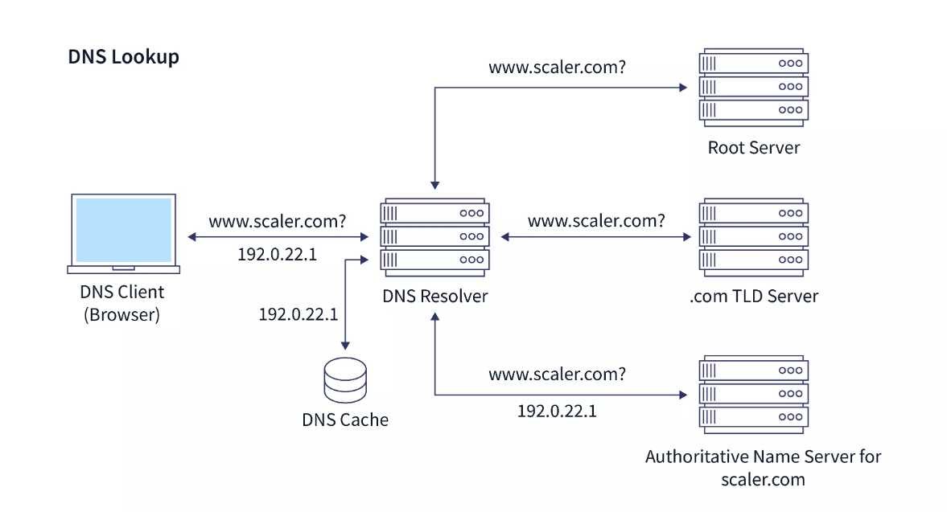
client and server architecture
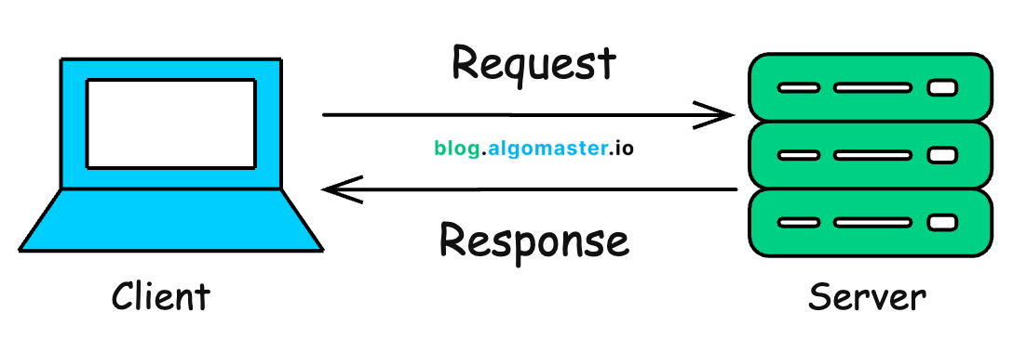
steps to run js:
- make js file and add in html page
- make js, install node
- open terminal and run node text.js

printing statement: console.log();

variables:
- think like a container (named container that stores value)
- we can store number, String, object, etc

1. var
2. let
3. const

/---------let------------
//when we declare a variable with let, we can reassign it. It is a mutable value.
//redeclaration of a variable with let is not allowed in the same scope.
let name="tarun";
let age=25;

console.log("My name is " + name + " and I am " + age + " years old.");
age=23; //reassign able
console.log("My name is " + name + " and I am " + age + " years old.");

//---------const------------
//when we declare a variable with const, we cannot reassign it. It is a constant value.
const pi=3.14;
console.log("The value of pi is " + pi);

//---------var------------
//when we declare a variable with var, we can reassign it. It is a mutable value.
//but it is not recommended to use var as it has some issues with scoping and hoisting.
var city="New York";
console.log("I live in " + city);

var city="Los Angeles"; //redeclaration is allowed with var
console.log("I live in " + city); //reassignable

---------var vs let------------
+ var is function scoped, while let is block scoped.
+ var can be redeclared and updated, while let can be updated but not redeclared in the same scope.

what is scope?
+ scope is the area of the code where a variable is defined and can be accessed.
+ There are three types of scope in JavaScript: global scope, function scope, and block scope.

Global Scope: variables declared outside of any function or block have global scope and can be accessed from anywhere in the code.
let b= 20; // b has global scope

function scope: variables declared inside a function have function scope and can only be accessed within that function.
function globalScopeExample() {
let a= 10; // a has function scope
console.log(a);
console.log(b); // b has global scope
}
globalScopeExample();
//console.log(a); //a has function scope and cannot be accessed outside the function

Block Scope: variables declared inside a block (e.g. if statement, for loop) have block scope and can only be accessed within that block.
{
let c= 30; // c has block scope
console.log(c);
var d= 40; // d has function scope
}
// console.log(c); // c has block scope and cannot be accessed outside the block
console.log(d); // d has function scope and can be accessed outside the block

Data Types
+ primitives: string, number, boolean, null, undefined, symbol, boolean, bigint
+ non-primitives: object, array, function

---------primitives------------
let str="Hello World"; //string
console.log(typeof str); //string

let num=25; //number
console.log(typeof num); //number

let bool=true; //boolean
console.log(typeof bool); //boolean

let n=null; //null
console.log(typeof n); //object

let u; //undefined
console.log(typeof u); //undefined

let sym=Symbol("id"); //symbol
console.log(typeof sym); //symbol

let bigInt=9007199254740991n; //bigint
console.log(typeof bigInt); //bigint

---------non-primitives------------
let arr = [1,2,3,4,5];
console.log(typeof arr); //object

let obj={name:"tarun", age:25}; //object
console.log(typeof obj); //object

function greet(name) { //function
return "Hello " + name;
}
console.log(typeof greet); //function
console.log(greet("tarun")); //function call //o/p: Hello tarun

-----------------------------------------------------------------------------------------------------------
operators
-----------------------------------------------------------------------------------------------------------

1. arithmetic operators -> +, -, *, /, %, **(exponential ex: 10**5 =>10^5)
console.log("Exponentiation: " + (a**b)); //Exponentiation: 100000

2. logical operators -> &&, ||, !
3. comparison operators -> ==, !=, ===, !==, <, >, <=, >= (== only compares values but === compares values with data types)
let m=10, n=20;
console.log("Equal to: " + (m==n)); //Equal to: false
console.log("Equal to: " + (m=="10")); //Equal to: true
console.log("Strictly equal to: " + (m===10)); //Strictly equal to: true

4. assignment operators -> =, +=, -=, *=, /=, %=
5. bitwise operators -> &, |, ^, ~, <<, >>
6. unary operators -> +, -, !, typeof, instanceof, ++, --
7. ternary operators -> condition ? expr1 : expr2
8. String Concatenation -> +
let fullName=firstName + " " + lastName;
console.log("Full Name: " + fullName); //Full Name: John Doe
let greeting=`Hello ${firstName} ${lastName}`; //template literal backticks important instead of quotes in development
console.log(greeting); //Hello John Doe
Control flow
-----------------------------------------------------------------------------------------------------------------
1. Conditional Statements: These allow the program to make decisions based on certain conditions. The most common conditional statements are if, else if, and else.
+They enable the execution of specific blocks of code depending on whether a condition evaluates to true or false.
+ The switch statement evaluates an expression and executes the corresponding case block based on the value of the expression.

2. Loops: Loops are used to execute a block of code repeatedly as long as a specified condition is true. Common types of loops include for, while, and do-while loops.

Functions
-----------------------------------------------------------------------------------------------------------------
1. Function declaration
function greet() {
console.log("Hello, World!");
}
greet();//function call

2. Function expression: Function can be stored in variable is called Function expression
Syntax: const var_name= function(){
.
function body
.
}
var_name(); // function call

3. Arrow function:
Syntax; const var_name = (Parameter) =>{ function body}
Syntax; const var_name = (Parameter) => return_value;

const add = (a, b) => a + b;
console.log("Sum: " + add(5, 3)); // fun call

4. Parameter and argument:
+ parameter: place holders in function (formal parameter)
+ arguments: actual values that are passed in function call (actual parameter)
function multiply(x, y) {
return x * y;
}
console.log("Product: " + multiply(4, 6));

5. Return Statement: to return the value

6. Default parameter: if we not pass the parameter in function call default parameter is used
function greetWithDefault(name = "Guest") {
console.log("Hello, " + name + "!");
}
greetWithDefault(); // Uses default parameter
greetWithDefault("Alice"); // Overrides default parameter

7. Function scope:
+ variable (var, let, const) created inside function can't accesed outside fun

8. callback functions: A callback function is a just a function that you pass to another function

function hello(name) {
console.log("Hello, " + name + "!");
}

function executeCallback(callback, name) {
callback(name);
}
executeCallback(hello ,name); // syntax: callback_function( function

// function hello is passed as a callback to executeCallback, which then calls hello with the name "Jane Doe".

-----------------------------------Object in js -------------------------------------------
+ An object is collection of key value pair
+ group of related data

1. creation:
const person = {
firstName: "John",
lastName: "Doe",
age: 30
};

2. Access and update values
console.log(person.firstName);
console.log(person.lastName);// dot notation
console.log(person["age"]);// bracket notation

person.age = 31; // Modifying(updating) object property
console.log(person.age);
3. adding or removing
person.address = "123 Main St"; // Adding new property
console.log(person);

delete person.address; // Deleting property
console.log(person.address); // undefined
console.log(person);

4. nested object
const student = {
name: "Alice",
age: 20,
address: {
city: "New York",
state: "NY"
}
};
console.log(student);
console.log(student.address.city);

5. object method(function inside object) and this keyword
const car = {
make: "Toyota",
model: "Camry",
year: 2020,
getCarInfo: function() {
return `${this.make} ${this.model} (${this.year})`;
}
};

console.log(car.getCarInfo());
------------------------------------
const car2 = {
make: "Toyota",
model: "Camry",
year: 2020,
getCarInfo(){
// return `${this.make} ${this.model} (${this.year})`;/
console.log(`${this.make} ${this.model} (${this.year})`);
}
};
car2.getCarInfo();

6. looping through object:
for (let key in person) {
if (person.hasOwnProperty(key)) {
console.log(key + ": " + person[key]);
}
}

Object.keys(car).forEach(key => { // Looping through object properties using Object.keys()
console.log(key + ": " + car[key]);
});

Object.values(person).forEach(value => { // Looping through object values using Object.values()
console.log(value);
});

7. object destructuring: Object destructuring is a feature that lets you extract properties from an object and store them in variables in a clean, concise way.
const { firstName, lastName } = person; //is equivalent to const name= person.name; and const age = person.age;
console.log(firstName);
console.log(lastName);

prototype in js object: prototype is a built-in object from which other objects inherit properties and methods.
-----------------------------------------------------------------------------
| Syntax | Description |
| --------------------------------------- | ------------------------------- |
| `const { name } = person;` | Extract a property |
| `const { name, age } = person;` | Extract multiple properties |
| `const { name: fullName } = person;` | Rename a variable |
| `const { age = 18 } = person;` | Set a default value |
| `const { name, ...rest } = person;` | Collect remaining properties |
| `function show({ name }) {}` | Destructure function parameters |
| `const { address: { city } } = person;` | Nested destructuring |
-----------------------------------------------------------------------------

----------------------------------Classes in JS-------------------------------------------

class is program code template for creating objects.
those objects will have some state(variables) and some behaviours(functions) inside it

class MyClass{
constructor(){......}
myMethod(){.......}
}

let myObj=new MyClass(); // creating object

example:
class ToyotaCar{
start(){
console.log("start");
}

stop(){
console.log("stop");
}

setBrand(brand){
this.brand=brand;
}
}

let fortuner=new fortuner();
fortuner.setBrand("fortuner");

Constructor() method
+ name should be constructor
+ autometicaly invoked by new
+ initializes object

class MyClass{
constructor(){......} // autometicaly / implecitly created
myMethod(){.......}
}

constructor with arg:
constructor(arg){......} // we acn pass arguments to constructor;
// but tere no compulsion to pass arguments if we don't pass the arguments it will be undifined;

Inheritance in JS
it is passing down propertes and methods from parent class to child class.

class Parent {
. .
}
class Child extends Paents{
. .
}

Note: If Child and parents have same methods, child's method will be used. (Method Overriding)

example:
class Parent {
constructor() {
this.name = 'Parent';
}
hello() {
console.log('Hello from Parent');
}

sleep() {
console.log('Parent is sleeping');
}
work() {
console.log('Parent is working');
}
}

class Child extends Parent {
work() {
super.sleep(); // Call the sleep method from Parent class
console.log('Child is working');
}
constructor() {
super();
this.name = 'Child';
}
}

let childInstance = new Child();
console.log(childInstance.name); // Output: Child
childInstance.hello(); // This will call the hello method from Parent class since it's not overridden in Child class
childInstance.work(); // This will call the work method from Child class

----------------------------------Arrays in JS---------------------------------------------

1. Creating of an array

2. Accessing and updating array elements
console.log(arr[0]);

//replace element
arr[0]=20;
console.log(arr[0]);

3. Array length
console.log(arr.length);

4. Iterating over an array
1. for loop
for(let i=0;i<colors.length;i++){
console.log(colors[i]);
}

2. foreach
colors.forEach(a=>{
console.log(a);
});

3. forof
for(let a of arr){
console.log(a);
};

5. Array methods (push, pop, shift, unshift, splice, slice, indexOf, includes)
1. push(); // add element to end
2. pop(); // remove last
3. shift(); // remove 1st element
4. indexOf(); //get index
5. join(); //join all elements in array to String
6. slice(); // extract part
7. splice(); //removes 1 item from index 1
let cart=[];

//add item
cart.push("T-shirt");
cart.push("shoes");
cart.push("watch");

console.log("cart item: ",cart);

// removing item
let popItem=cart.pop();
console.log("pop item",popItem);
console.log("cart item: ",cart);

//indexOf
console.log(cart.indexOf("shoes")); // returns index of shoes

//includes
console.log(cart.includes("shoes")); // returns true if shoes is in the array

//join
console.log(cart.join(", ")); // returns string of all items in the array

//slice
let newCart=cart.slice(0,1); // returns new array with items from index 0 to 1
console.log("new cart: ",newCart);

//splice
cart.splice(1,1);// removes 1 item from index 1
console.log("cart item: ",cart);

6. Multidimensional arrays
let matrix=[
[1,2,3],
[4,5,6],
[7,8,9]
];
console.log(matrix);

7. Array destructuring: extract values from an array and store them in variables in a simple and readable way.
const colors=["red", "green", "blue", "yellow", "purple", "orange"];
let [a,b,c]=colors; // first 3 values stores in a, b, c
console.log(a,b,c);

-------------------------------------------------------------------------------------------

-------------------------------------------String in JS------------------------------------
let name="Tarun";
let message=`Welcome ${name} to the world of JavaScript`;//dynamic string
console.log(message);

name[0]="t"; // strings are immutable, this will not change the string
console.log(name); // Output: Tarun

name="tarun"; // reassigning the variable to a new string
console.log(name); // Output: tarun

let str="Hello World";
console.log(str[0]); // accessing first character
console.log(str[6]); // accessing character at index 6

console.log(str.length); // length of string

//String methods
console.log(str.length);// length of string
console.log(str.toUpperCase());// converts string to uppercase
console.log(str.toLowerCase()); //converts string to lowercase
console.log(str.indexOf("World")); // returns index of "World" in the string
console.log(str.includes("Hello")); // returns true if "Hello" is in the string
console.log(str.slice(0, 5)); // extracts "Hello"
console.log(str.replace("World", "JavaScript")); // replaces "World" with "JavaScript"
console.log(str.split(" ")); // splits the string into an array of words
console.log(str.trim()); // removes whitespace from both ends of the string
console.log(str.charAt(4)); // returns character at index 4

//type conversion
let num=123;
let strNum=String(num); // converts number to string
console.log(typeof strNum); // Output: string
let str5=num.toString(); // another way to convert number to string

let ss="456";
let num2=Number(ss); // converts string to number
console.log(typeof num2);

let bool=Boolean(num2); // converts number to boolean
console.log(bool); // Output: true

----------------------------------Async-wait-----------------------------------------------
async and await are JavaScript features that make asynchronous code look and behave like synchronous code, making it much easier to read and write.

async await >> promise chains >> callback hell

Sync in JS:
-----------

Synchronous:
Synchronous means the code runs in a particular sequence of instructions given in the program.

Asynchronous:
Each instruction waits for the previous instruction to complete its execution.
Due to synchronous programming, sometimes imp instructions get blocked due to some previous instructions, which causes a delay in the UI. Asynchronous code execution allows to execute next instructions immediately and doesn't block the flow.

+ Callbacks: A callback is a function passed as an argument to another function.

What is Synchronous Programming?
JavaScript executes code one line at a time.

The Problem..... Imagine downloading a large file.
downloadFile(); // takes 10 seconds
console.log("Done");

Callback Hell
--------------
Callback Hell: Nested callbacks stacked below one another forming a pyramind structure.

Promises:
---------
+ Promise is for “eventual” completion of task. It is an object in JS.
+ It is a solution to callback hell.

let promise = new Promise( (resolve, reject) => { .... } )
Function with 2 handlers
*resolve & reject are callbacks provided by JS

Promises
A JavaScript Promise object can be:
+ Pending : the result is undefined
+ Resolved : the result is a value (fulfilled) resolve( result )
+ Rejected : the result is an error object reject( error )

*Promise has state (pending, fulfilled) & some result (result for resolve & error for reject).

Promises can be used by
.then( ) & .catch( )
promise.then( ( res ) => { .... } )
promise.catch( ( err ) ) => { .... } )

Pending
↓
Fulfilled
or
Rejected

const promise = new Promise((resolve, reject) => {
resolve("Success");
});

promise
.then(result => {
console.log(result);
})
.catch(error => {
console.log(error);
});

Async-Await:
------------
async function always returns a promise.
async function myFunc( ) { .... }
await pauses the execution of its surrounding async function until the promise is settled.

.
The Problem..... Imagine downloading a large file.
downloadFile(); // takes 10 seconds
console.log("Done");
"Start downloading. I'll continue doing other work. Tell me when it's finished."

Start Download
│
▼
Continue Running Code
│
▼
Download Completes
│
▼
Run Callback

ex:
console.log("Start");
setTimeout(() => {
console.log("Downloaded");
}, 3000);
console.log("End");

output :
Start
End
Downloaded

+ JavaScript is single-threaded.
+ async always returns a Promise.
+ await waits for a Promise inside an async function.
+ await does not block the entire program—only the current async function.

---------------------------------- DOM ---------------------------------------------------
# JavaScript DOM (Document Object Model) – Complete Notes
The Document Object Model (DOM) is a programming interface for HTML and XML documents. It represents the webpage as a tree of objects, allowing JavaScript to access, modify, add, or remove HTML elements dynamically.

# What is the DOM?
When a browser loads an HTML document, it converts it into a tree-like structure called the DOM Tree.
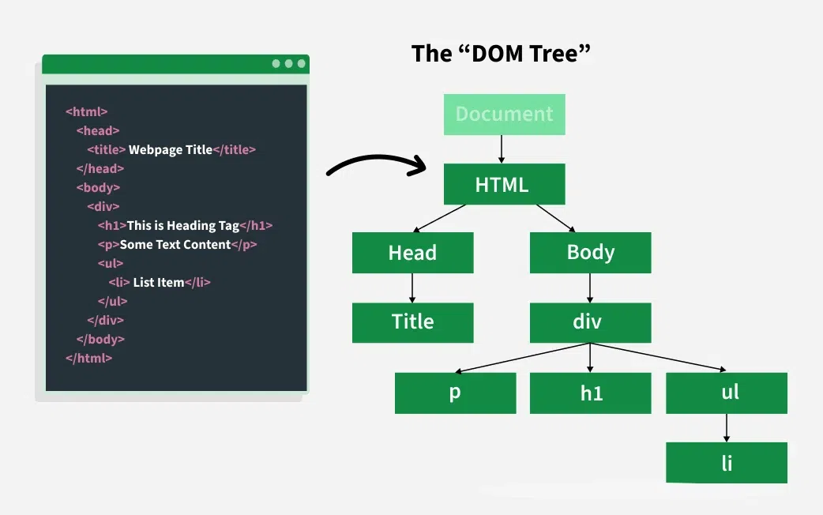
+ The document object is created by the browser (Chrome, Edge, Firefox), not by Node.js.
+ Every HTML element becomes an object that JavaScript can manipulate.

Document object model
1.Accessing elements by ID:
const titleElement = document.getElementById("title");
console.log(titleElement.textContent); // Output: DOM Understanding
console.log(titleElement.innerHTML); // Output: DOM Understanding
console.log(titleElement.innerText); // Output: DOM Understanding
console.log(titleElement.outerHTML); // Output: <h1 id="title">DOM Understanding</h1>

# Common DOM Selection Methods
+ ----------------------------------------------------------------------- +
| Method | Returns |
| -------------------------------------- | ------------------------------ |
| `getElementById()` | Single element |
| `getElementsByClassName()` | HTMLCollection |
| `getElementsByTagName()` | HTMLCollection |
| `querySelector()` | First matching element |
| `querySelectorAll()` | NodeList |
+ ----------------------------------------------------------------------- +

Accessing elements by class name
const descriptionElements =
document.getElementsByClassName("description");
console.log(descriptionElements[0].textContent); // Output: This is a paragraph with a class attribute.

Accessing elements by tag name
const listItems = document.getElementsByTagName("li");
console.log(listItems.length); // Output: 3
console.log(listItems[0].textContent); // Output: Item 1

Accessing elements using querySelector
const firstListItem = document.querySelector("li");
console.log(firstListItem.textContent); // Output: Item 1

accessing elements using querySelector by ID
const listElement = document.querySelector("#list");
console.log(listElement.textContent); // Output: Item 1Item 2Item 3

accessing elements using querySelector by class
const descriptionElement = document.querySelector(".description");
console.log(descriptionElement.textContent); // Output: This is a paragraph with a class attribute.

Accessing elements using querySelectorAll
const allListItems = document.querySelectorAll("li"); //Returns a NodeList of all matching elements.
console.log(allListItems.length); // Output: 3

# `textContent` vs `innerHTML` vs `innerText`
-----------------------------------------------------------------------------------------------------
These three DOM properties are used to read or modify the content of an HTML element, but each behaves differently.

1. `textContent: textContent returns or sets all the text inside an element, including text inside child elements. It ignores HTML tags and includes hidden text.

### Example

```html
<p id="demo">
Hello <b>World</b>
<span style="display:none">Hidden</span>
</p>
```javascript
const demo = document.getElementById("demo");
console.log(demo.textContent);
```

### Output
Hello World Hidden

### Characteristics

* Returns only text (no HTML tags).
* Includes hidden text (`display: none`, `visibility: hidden`).
* Ignores CSS styling.
* Faster than `innerText` because it does not calculate styles.
* Can also be used to replace all text inside an element.

# 2. `innerText`: `innerText` returns or sets **only the text that is visible on the webpage**.

### Example

```html
<p id="demo">
Hello <b>World</b>
<span style="display:none">Hidden</span>
</p>
```javascript
console.log(demo.innerText);
```

### Output

Hello World //The word **Hidden** is not returned because it is not visible.

### Characteristics

* Returns visible text only.
* Ignores hidden elements.
* Respects CSS (`display`, `visibility`, etc.).
* Preserves line breaks as shown on the page.
* Slightly slower because the browser must calculate the rendered layout.

# 3. `innerHTML`: `innerHTML` returns or sets the **HTML markup inside an element**, including all child tags.

### Example

```html
<p id="demo">
Hello <b>World</b>
</p>
```javascript
console.log(demo.innerHTML);
```

### Output

```html
Hello <b>World</b>
```

### Characteristics

* Returns HTML along with text.
* Includes all child elements and tags.
* Can be used to create or replace HTML dynamically.
* Useful for adding formatted content.
* Be careful when inserting user input, as it can lead to **Cross-Site Scripting (XSS)** vulnerabilities.
# Visual Example

### HTML

```html
<p id="demo">
Hello
<b>World</b>
<span style="display:none">Hidden</span>
</p>
```

### JavaScript

```javascript
const demo = document.getElementById("demo");

console.log(demo.textContent);
console.log(demo.innerText);
console.log(demo.innerHTML);
```

### Output:
| `textContent` | `Hello World Hidden |
| `innerText` | `Hello World` |
| `innerHTML` | `Hello <b>World</b> <span style="display:none">Hidden</span>` |

| Feature | textContent | `innerText` | `innerHTML` |
| ------------------------- | --------------- | -------------- | ----------------- |
| Returns text | ✅ Yes | ✅ Yes | ✅ Yes |
| Returns HTML tags | ❌ No | ❌ No | ✅ Yes |
| Includes hidden text | ✅ Yes | ❌ No | ✅ Yes (as HTML) |
| Respects CSS | ❌ No | ✅ Yes | ❌ No |
| Preserves HTML formatting | ❌ No | ❌ No | ✅ Yes |
| Can modify HTML | ❌ No | ❌ No | ✅ Yes |
| Performance | Fastest | Slower | Moderate |

# Quick Revision

* `textContent` → Plain text, includes hidden text, ignores HTML tags.
* `innerText` → Only visible text, respects CSS, ignores hidden content.
* `innerHTML` → Returns or sets HTML markup, including child elements and tags.

-----------------------------------------------------------------------------------

----------------------DOM manipulation -------------------------------------------

//accessing the text content of the div
node.textContent()

ex:
const mylist=document.querySelector("#mylist");
console.log(mylist);
console.log(mylist.textContent);
console.log(mylist.innerHTML);

//modifying the HTML content of the div
node.textContent()="new Text"

mylist.innerText="This is a new text content.";
mydiv.innerHTML="<p>This is a new paragraph.</p>";

//accessing the attribute value of any node
node.getAttribute("Attribute")

//to set attribute
node.setAttribute("Attribute", "value");

//style we can access and modifies
node.style
node.style.property="value"

// Inserting Element
2 steps:
-------
1.Create Element
let el=document.createElement("node"); node-> p,div,h1-h6,li,button...etc

2.append(4 ways/ positions)
node.append(el); //adds at the end of node(inside)
node.preappend(el); //adds at the start of node(inside)
node.before(el); //adds before the node(outside)
node.after(el); //adds after the node(outside)

//Delete Element
node.remove

-----------------------------------------------------------------------------------

--------------------------------event Handeling------------------------------------

The change in the state of an object is known as an Event

+ Mouse events (click, double click etc.)
+ Keyboard events (keypress, keyup, keydown)
+ Form events (submit etc.)
+ Print event & many more

Event Handling in JS (if w defined multifile handler last handling will override all)
--------------------
node.event = ( ) => {
//handle here
}

btn.onclick = ( ) => {
console.log(“btn was clicked”);
}

+ Event Object: It is a special object that has details about the event.
All event handlers have access to the Event Object's properties and methods.
node.event = (e) => {
//handle here
}

e.target, e.type, e.clientX, e.clientY

Event Listeners
---------------
+ node.addEventListener( event, callback )
ex: bt1.addEventListener("click", (e)=>{ console.log();});
+ node.removeEventListener( event, callback)

--------------------------------Fetch API------------------------------------------

const response=await fetch(URL);

+ fetch(URL) sends an HTTP request to the given URL.
+ fetch() returns a Promise.
+ The Promise resolves to a Response object.
+ await pauses the async function until that Promise is resolved.
+ So response contains the server's HTTP response, not the actual JSON data yet.

const data=await response.json();

+ response.json() reads the response body and parses it as JSON.
+ response.json() also returns a Promise.
+ await waits for that Promise to resolve.
+ data contains the actual JavaScript object/array obtained from the JSON.

Note: One important point: fetch() does not reject its Promise for HTTP errors like 404 or 500. You normally check response.ok before parsing/using the data.

